**SHACMAN H3000 6X4 DUMP Truck自卸车**

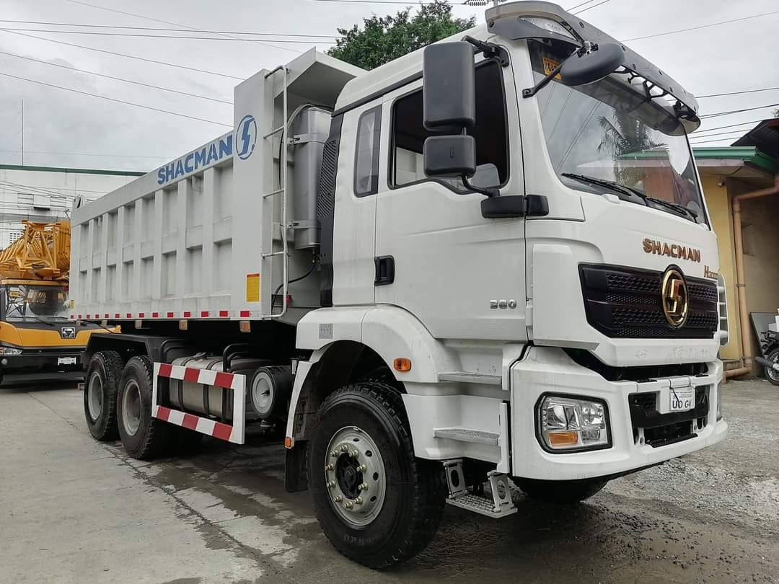

图片仅供参考

Pictures are for reference only

**Main Specifications主要参数**

|  |  |  |
| --- | --- | --- |
| MODEL/车型 | | SX3255MR384 |
| Driver position/驾驶员位置 | | 左舵 Left Hand |
| Driving type/驱动形式 | | 6*4 |
| Wheelbase/轴距(mm) | | 3775+1400 |
| Max. Speed/最高车速(km/h) | | 75km/h |
| Engine/发动机 | Brand/品牌 | WEICHAI/潍柴 |
| Model/型号 | WP10.340E22 |
| Emission Standard/排放 | EURO II |
| Rated output power/功率（PS） | 300 |
| Displacement  (L)/排量 | 9.726L |
| Transmission/变速箱 | Brand/品牌 | FAST/法士特 |
| Model/型号 | 10JSD180T-B-  QH50 |
| Front axle/前轴 | Brand/品牌 | 汉德牌/HANDE |
| Model/型号 | MAN 9.5T |
| Rear axle/后桥 | Brand/品牌 | 汉德牌/HANDE |
| Model/型号 | 16T MAN双级桥 double reduction driving axle  Speed ratio 速比：5.262 |
| Clutch/离合器 | | ￠430 diaphragm clutch￠430离合器 |
| Steering/转向机 | | ZF technology/ ZF技术 |
| Frame/车架 | | 850x300(8+7) |
| Suspension/悬架 | | Front and rear multi-leaf spring four main flims+four horse riding  前后多片簧  四主片+四骑马 |
| Fuel tank/燃油箱 | | 400L铝合金 Aluminum alloy |
| Wheels and tires/轮胎 | | 12.00R20 |
| Brakes/制动 | | Running brake:Dual circuit compressed air brake/行车制动 |
| Parking brake:Air discharging with spring control/停车制动 |
| Auxiliary brake:Engine exhaust brake/发动机排气辅助制动 |
| Cabin/驾驶室 | | 空气主座椅、四点空气悬浮驾驶室、电控自动恒温空调、电动摇窗机、手动翻转、普通空滤、、平板安装板、金属保险杠、铰链式上车踏板、分体式挡泥板、165Ah维护蓄电池、SHACMAN识、全英文标识 |
| Air main seat, four-point air suspension cab, electronically controlled automatic constant temperature air conditioner, electric window shaker, manual flip, ordinary air filter, , flat mounting plate, metal bumper, hinged upper car  Pedals, split fenders, 165Ah maintenance battery maintenance battery as standard), SHACMAN logo, full English logo |
| Upbody/上装 | | 5800*2300*1500 底10边8 |

|  |
| --- |
|  |
| Description/说明：   1. Terms of payment: T/T, 30% deposit, balance before delivery from factory.   支付条件：预付30%，工厂发车前付清尾款   1. Delivery at China port period: 45 working days after advance payment.   交货期：预付款后45个工作日到国内港口   1. Vehicle warranty period: 24 months from the date of bill of lading.   整车质保期：提单之日起24个月 |